Lab 7: Finite State Machines

Author: Seth Ricks
Date: 11/12/2025
Class: ECEN 340
Objectives:
- Learn how to design simple finite state machines.
- Learn how to design timers and precise clock frequencies.
- Learn how to implement a simple state machine in Verilog.
Procedure:
Design and implement a traffic controller for a Main Street / Center Street intersection. The recommended state graph for the controller is:
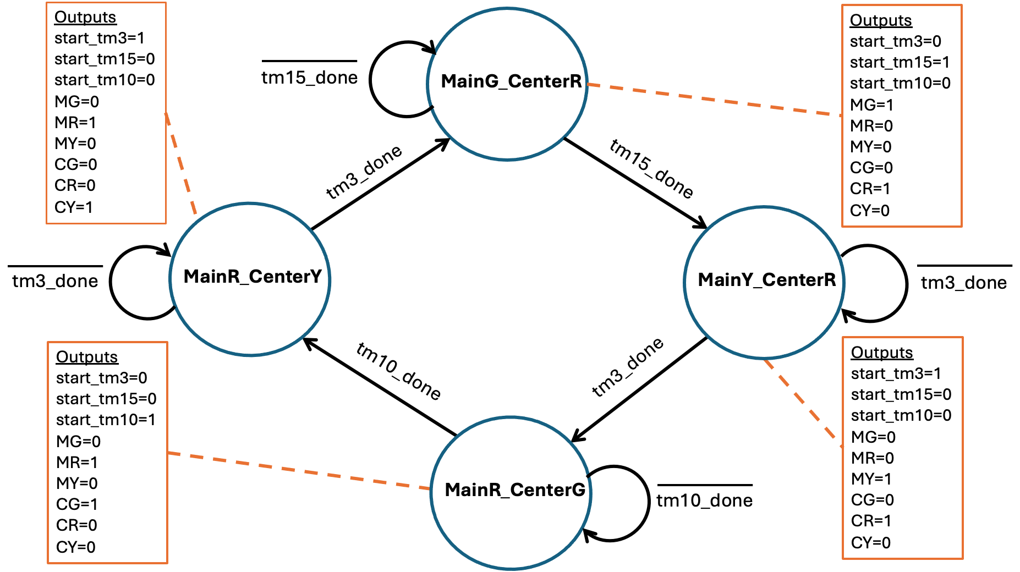

    - LED 0: Main Street Green Light
    - LED 1: Main Street Yellow Light
    - LED 2: Main Street Red Light
    - LED 4: Center Street Green Light
    - LED 5: Center Street Yellow Light
    - LED 6: Center Street Red Light

Key Requirements:
- The state machine clock rate will be 100MHz
- Use parameters to represent the state names
- Design a state machine with Moore outputs
- Use a dedicated "always" block with a case statement to implement the next state logic
- Use a dedicated "always" block to advance the current state to the next state
- Design a 1 Hz clock signal for the state machine
- Design a 3 second timer for the yellow lights
- Design a 15 second timer for the main street green light
- Design a 10 second timer for the center street green light

State Names
- MainG_CenterR - Main street light is green, Center street light is red
- MainY_CenterR - Main street light is yellow, Center street light is red
- MainR_CenterG - Main street light is red, Center street light is green
- MainR_CenterY - Main street light is red, Center street light is yellow

Inputs to the State Machine
- tm_done - indicates the completion of the 3-second timer
- tm10_done - indicates the completion of the 10-second timer
- tm15_done - indicates the completion of the 15-second timer

Outputs of the State Machine
- start_tm3 - Start the 3-second timer
- start_tm15 - Start the 15-second timer
- start_tm10 - Start the 10-second timer
- MG - Main street green light
- MR - Main street red light
- MY - Main street yellow light
- CG - Center street green light
- CR - Center street red light
- CY - Center street yellow light

Behavior of timers
The timers will receive their respective start signal and turn that signal into a 10ns start pulse. This can be done with a flip-flop and an AND gate. This circuit is referred to as a "step to pulse converter". The start pulse will initialize the timer circuit, and the timer will count to the terminal count before asserting the respective "tmx_done" signal.

Results/Report:

Part 1:
The very first thing that we had to do was create a module. We did so, and called it ‘traffic light’. The beginning of this module can be seen in Figure 1 below. This figure includes the module definition, the parameters for the states, the flags for when all three timers finish, some declarations of other variables, and the assignments from the state machine outputs to the LEDs.
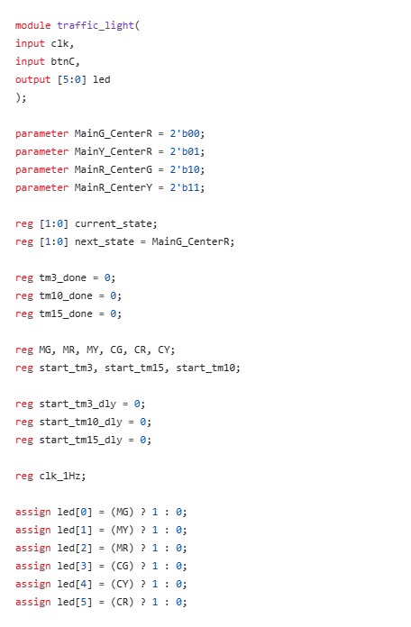
Figure 1: ‘traffic_light’ module
We then created an always block for the next state logic. From the state graph, we knew that a change in state is purely dependent on the timers being completed. In other words, the only variables that we should have in the next state logic is the ‘tm15_done,’ ‘tm10_done,’ and ‘tm5_done.’ The always block with our next state logic can be seen in Figure 2 below.

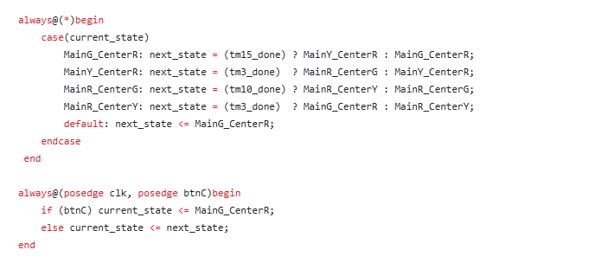
Figure 2: Next State Logic

But what happens when we move to another state? Because this is a moore machine, the outputs happen when we are in the states themselves, and are not at all related to the inputs. So, we created another always block that contains a case statement, with the outputs for each state. In the case of this particular state machine, the outputs are the LEDs that represent our green, yellow, and red lights for both center and main street. These are represented by ‘MG, MR, MY, CG, CR, and CY.’ In Figure 1, we assign these variables directly to the board’s leds, so that we can see the transitions when we run this code directly on the board. An image of the always block containing the state output logic can be seen in Figure 3 below.
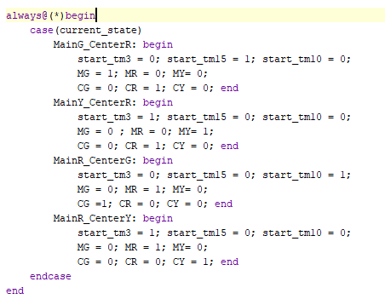
Figure 3: State Output Logic

Can you imagine if the traffic light changed states at 100MHz? It would be so fast that the human eye would register all the red, green, and yellow lights on both sides of the street as on at the same time. That would sure cause some accidents. To prevent this, we created a much slower clock for the timers to use. We did this by taking out 100 MHz clock and slowing it way down to 1Hz. An image of this logic can be seen in Figure 4 below.
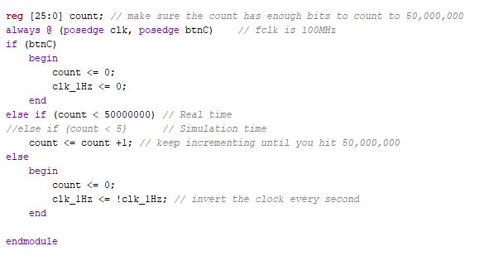
Figure 4: 100MHz to 1Hz Clock
Of course we don’t want each clock to change once a second, that would also cause chaos. So we need three separate timers: One for 3 seconds, one for 10 seconds, and one for 15 seconds. These timers are special in the way that they emit a single pulse when they are completed. It is upon this pulse that the changes in states are triggered. Images of these three timers can be seen in Figures 5-7 below.
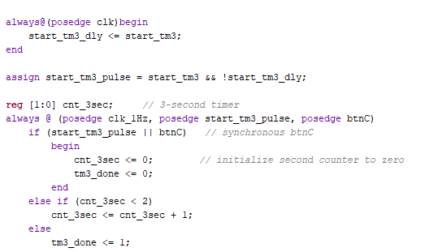
Figure 5: 3 Second Timer with Single Pulse
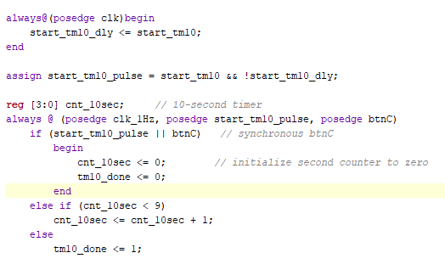
Figure 6: 10 Second Timer with Single Pulse
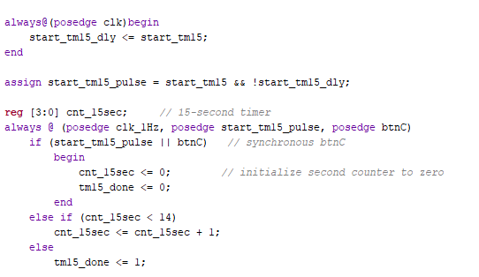
Figure 7: 15 Second Timer with Single Pulse

With our source code completed, we were ready to create our testbench. We tried to keep this simple. All we did was change our 1Hz clock from before to be much faster for the simulation, and then call our traffic_light module for our unit under test. We then toggled the clock every 5 ns, and observed the outputs in our waveform viewer. Our testbench module code can be seen in Figure 8 below.
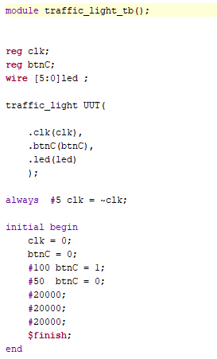
Figure 8: Traffic Light Testbench Code

As expected, our state machine had the pattern as follows: MainG_CenterR, MainY_CenterR, MainR_CenterG, MainR_CenterY, back to MainG_CenterR. This can be seen in Figure 9 below, with the states changing in the pattern “0, 1, 2, 3, 0…”.

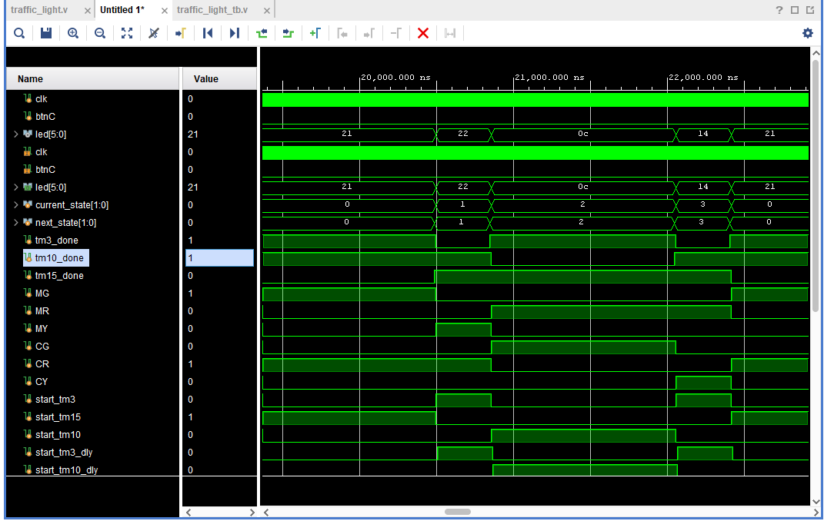
Figure 9: Traffic Light Waveforms

To tie it all together, we tested the code on the physical board. The LEDs changed as expected, with the green light on one side being held for 15 seconds, going yellow for 3 seconds, then switching red with green on the opposite street. Another 15 seconds is held, and then the opposite pattern is seen. This can be seen in Figures 10-14 below. Our lights are in the order of Center Street (3 LEDs) and then Main Street (3 LEDs). Each is in the sequence of “red, yellow, green” looking from left to right.

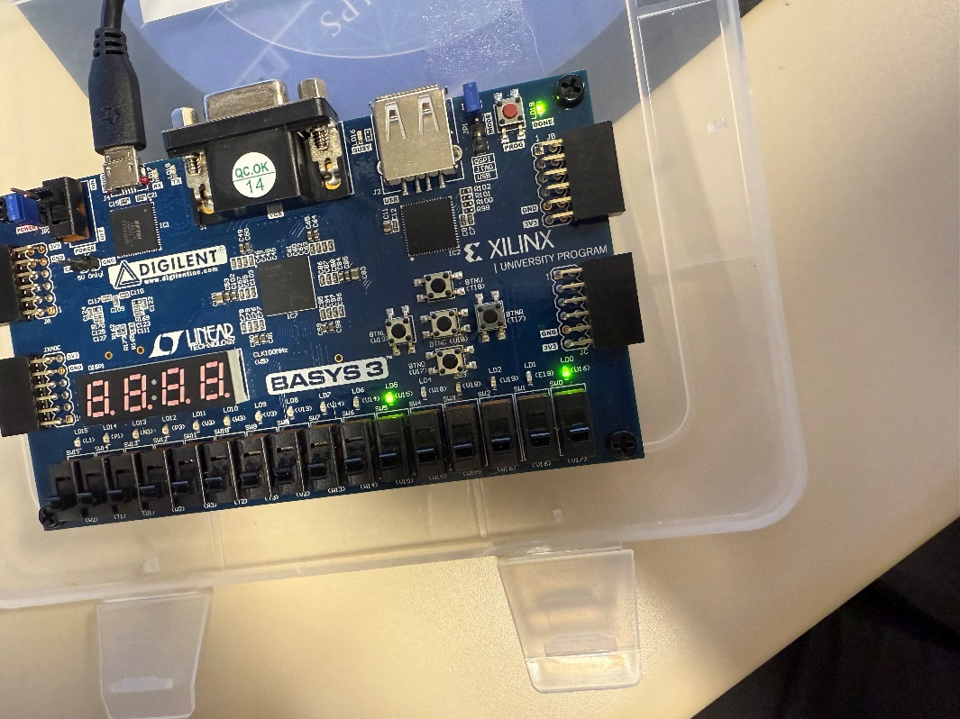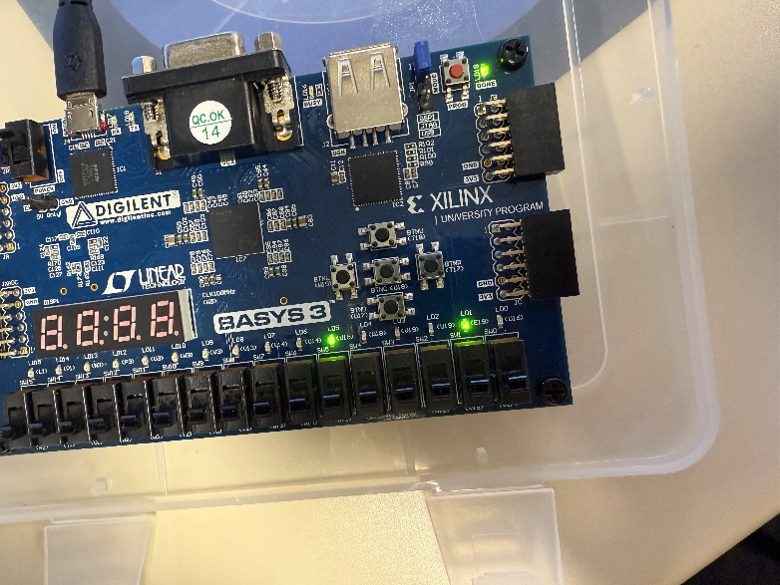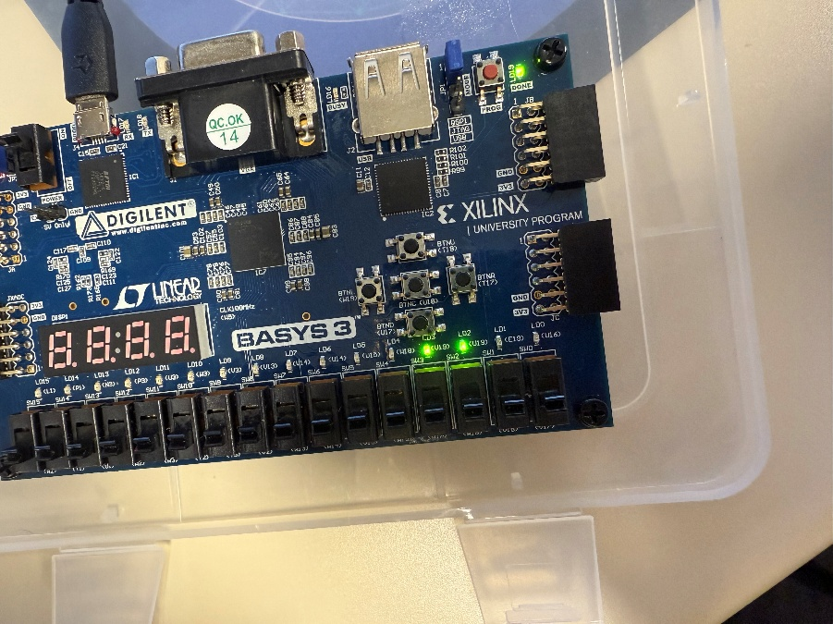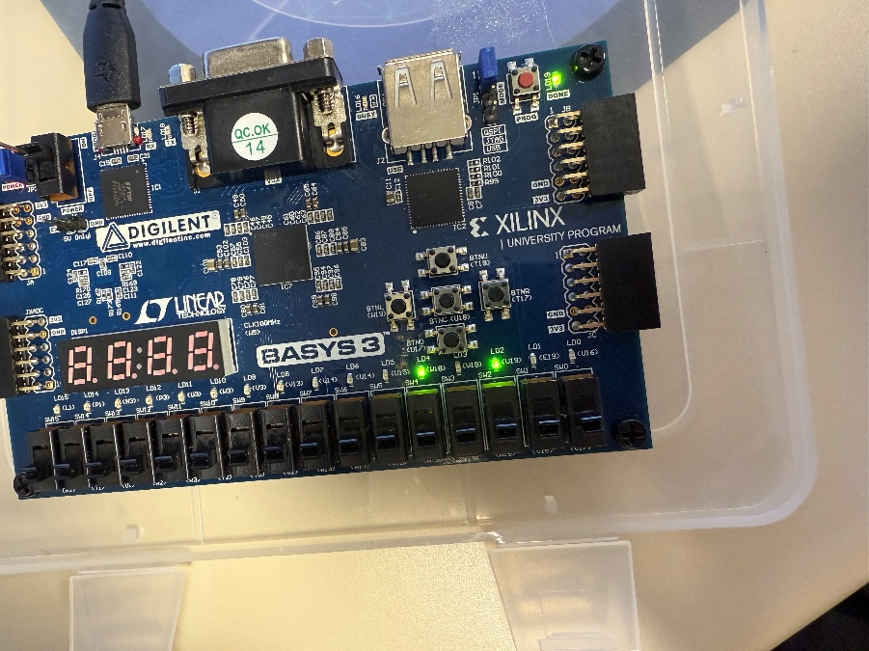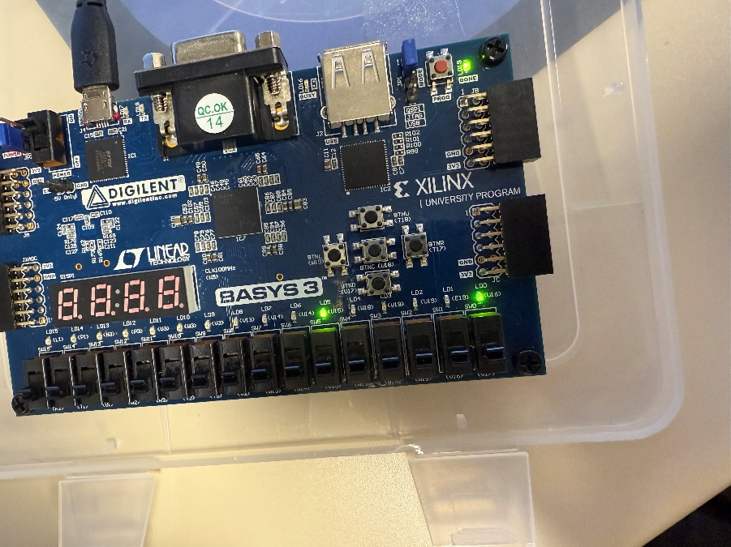
Figures 10-14: State Machine LED Sequence
To wrap things up, we took a look at the schematic. It was very complicated, and we didn’t even attempt to understand it. An image of this schematic can be seen in Figure 11 below.
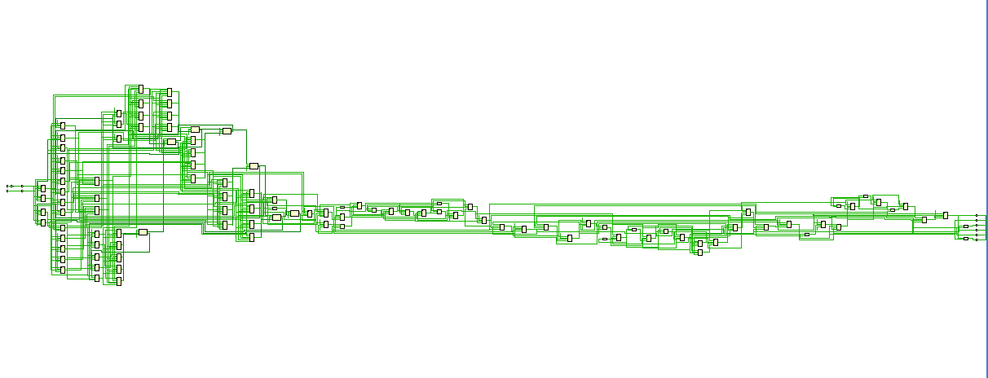
Figure 11: Schematic of Traffic Light State machine

Conclusion:
Overall, this was a very informative lab. We expanded on the knowledge we gained in HW7, by creating our own state machine from scratch. The main hangup for us was a small and silent error in each of our timers. Instead of declaring cnt_15sec and cnt_10sec with enough bits to hold 10 and 15 seconds respectively, we had kept it as 2 bits. This was because we had copied and pasted the code from our 3 second timer over to make the other two timers. We figured out this issue by looking at the waveform viewer, and noticing that the count for the 10 and 15 second timers were stopping at 2 and looping back to 0. After we fixed this issue, our state machine worked as intended.

